**Alekhya Krishna Balivada Azure Databricks Assessment -4 (02-01-2024)**

**Creating Delta-Lake tables in Azure Databricks:**

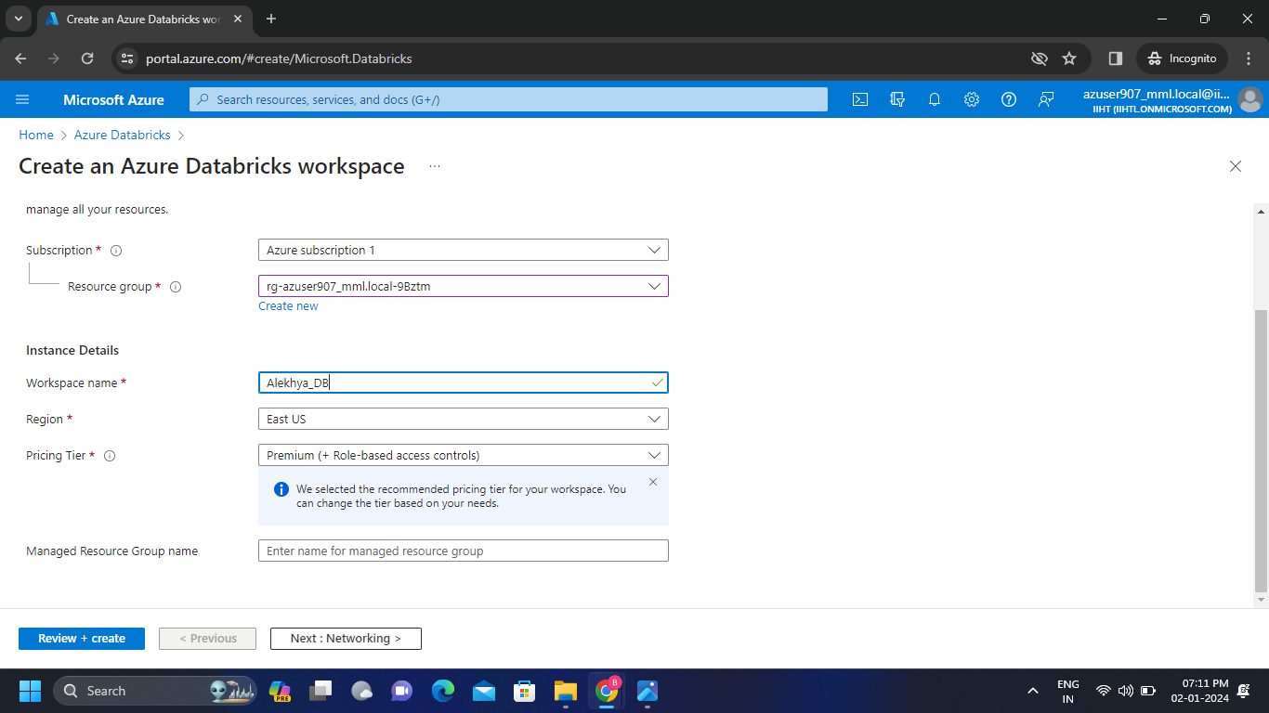**Step-1:** Create a workspace in the existing resource available.

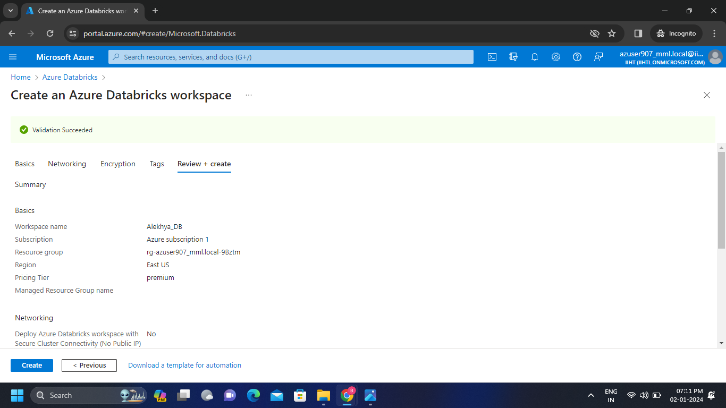

**Step-2:** Create a new cluster.

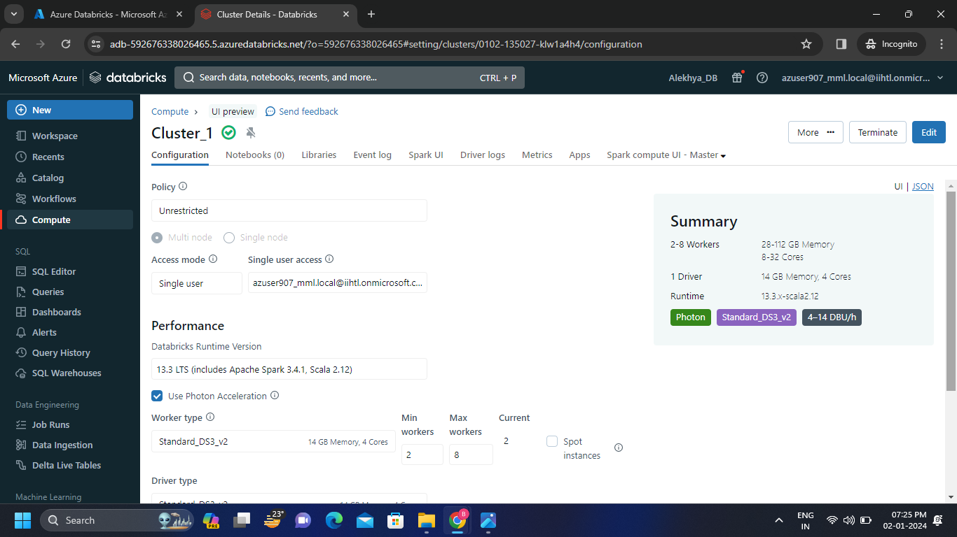

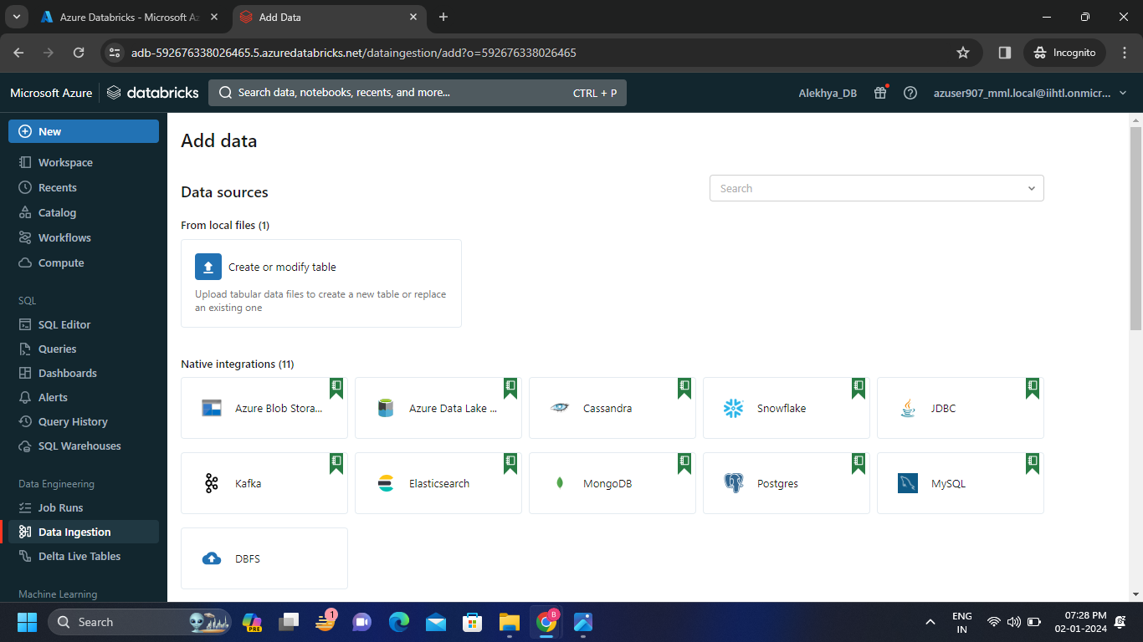**Step-3:** Click on Data ingestion then upload the csv file by clicking on create or modify table.

**Step-4:** Browse the files from the local files and upload it.

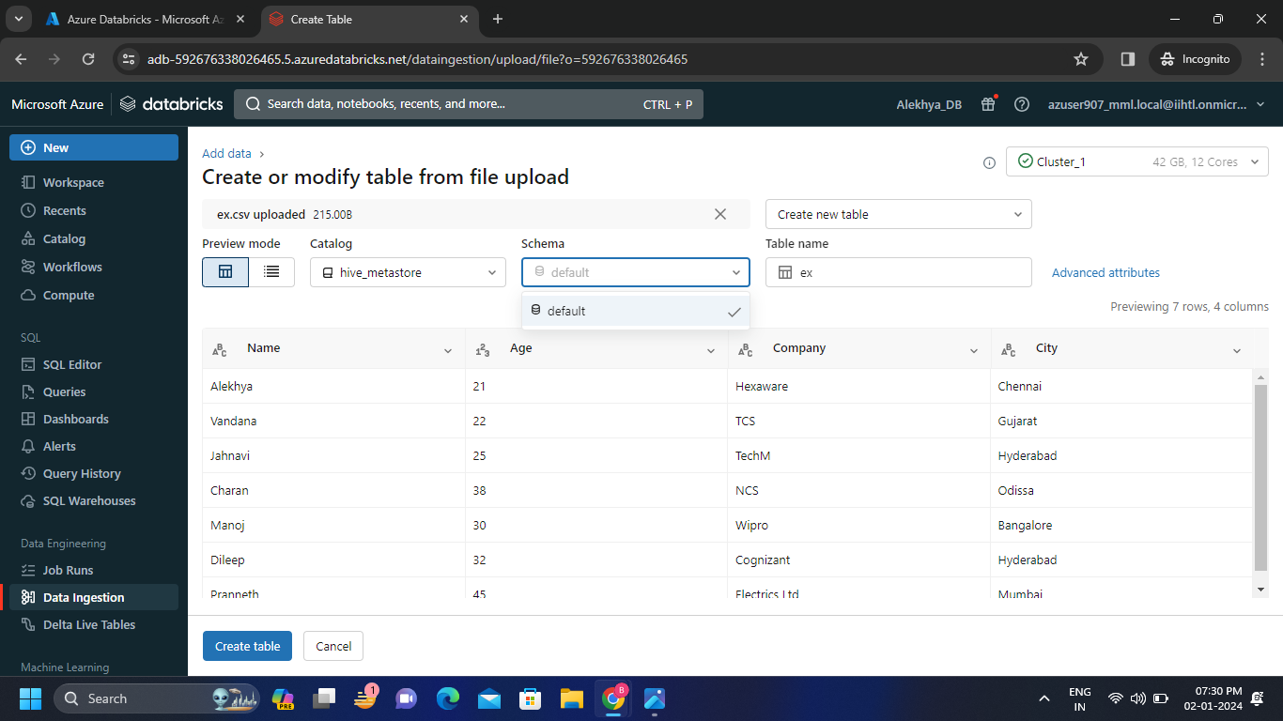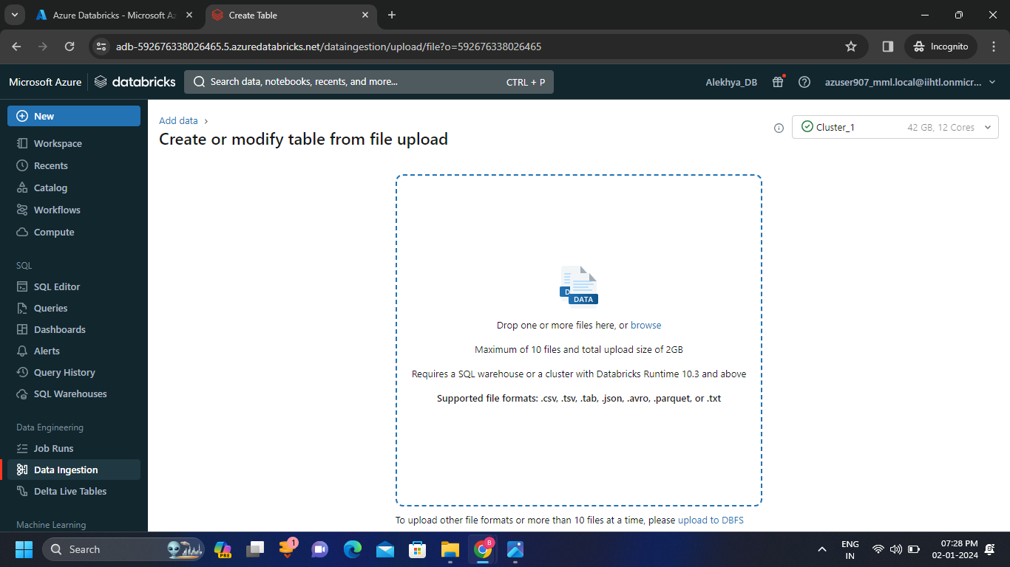

**Step-5:** Create the table by clicking on create table.

* Now click on create and then we get the pop-up of create query/notebook/quick dashboard click on notebook to run the queries.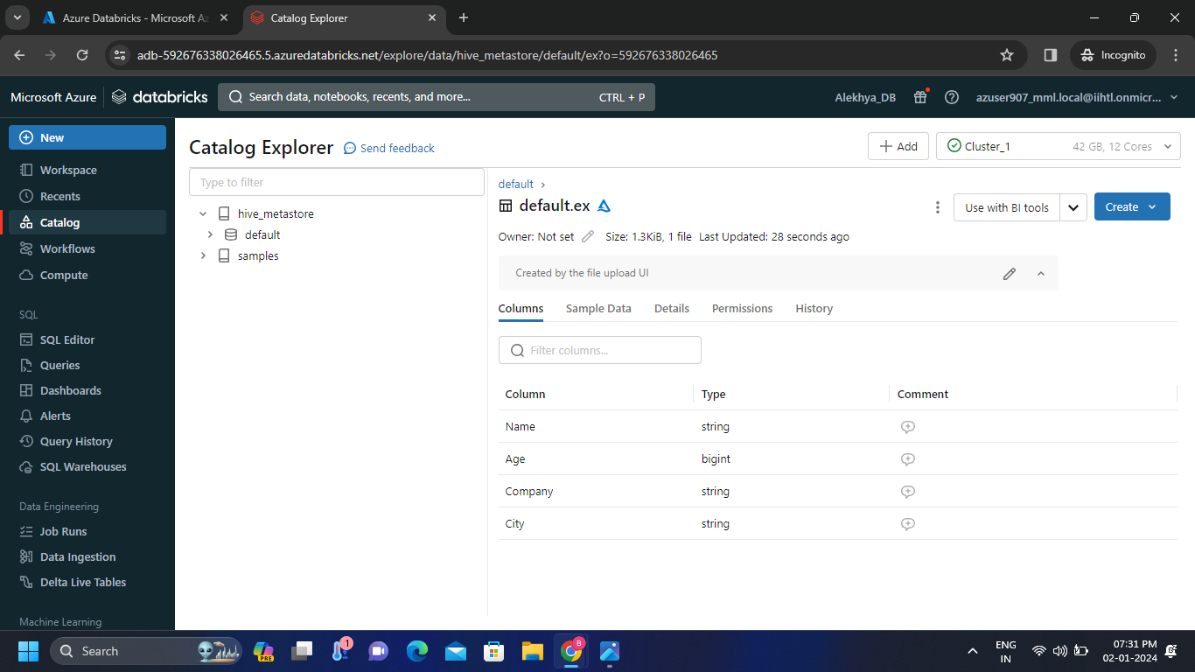

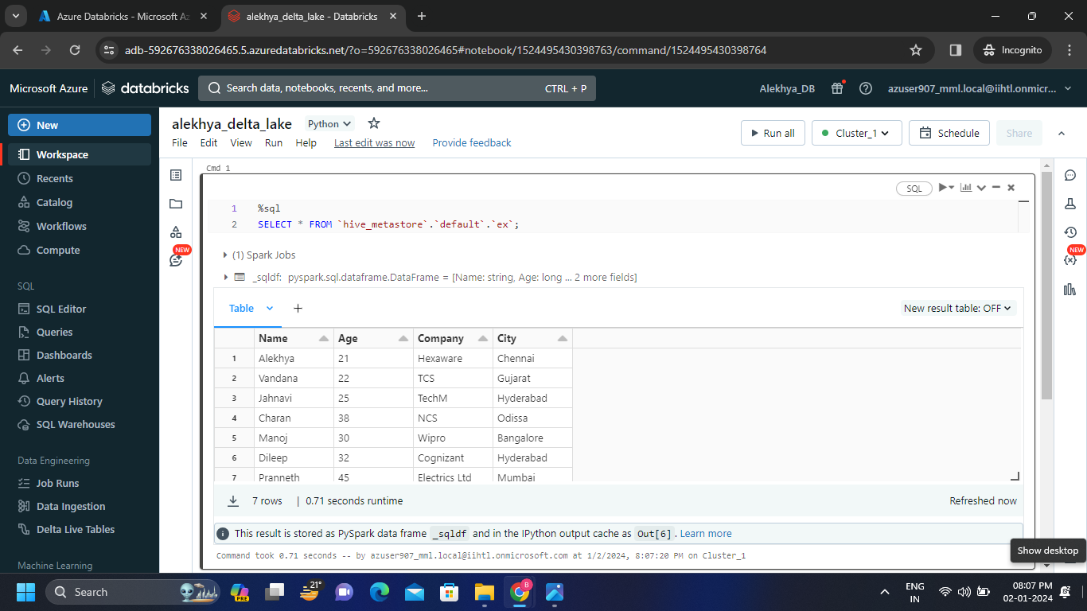**Step-6:** Run the query so that we get the output as follows.

**Creating Delta-Lake tables in Azure Databricks Free Account:**

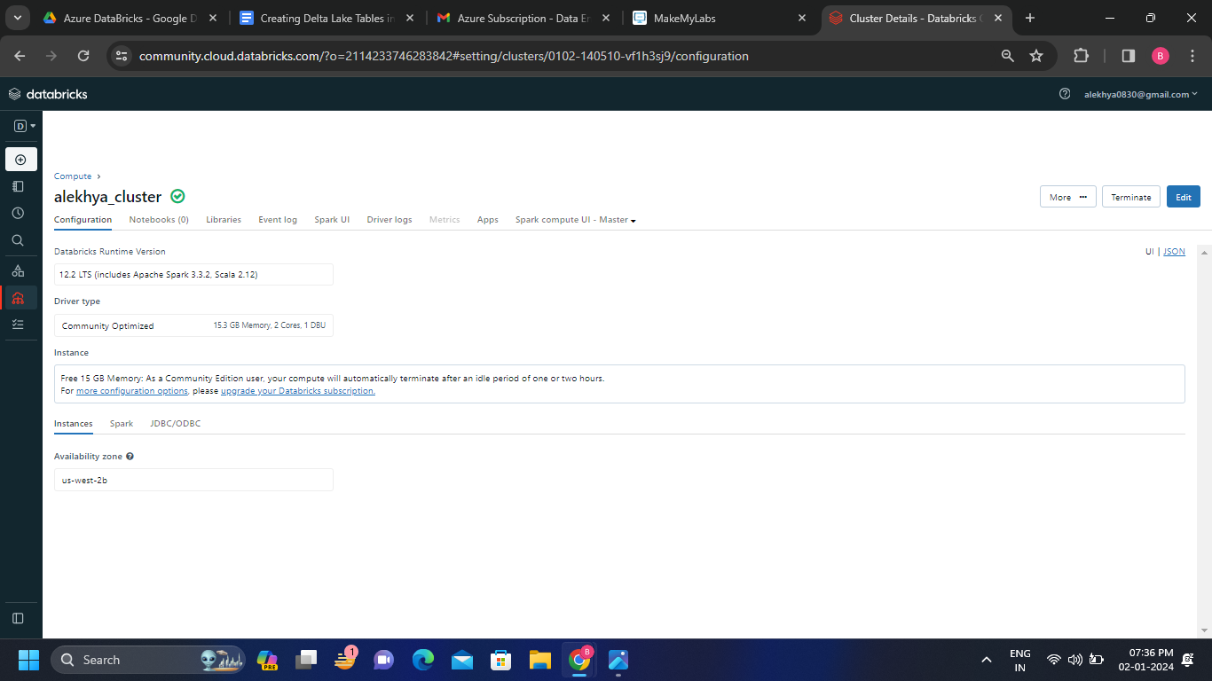**Step-1:** Create a new cluster.

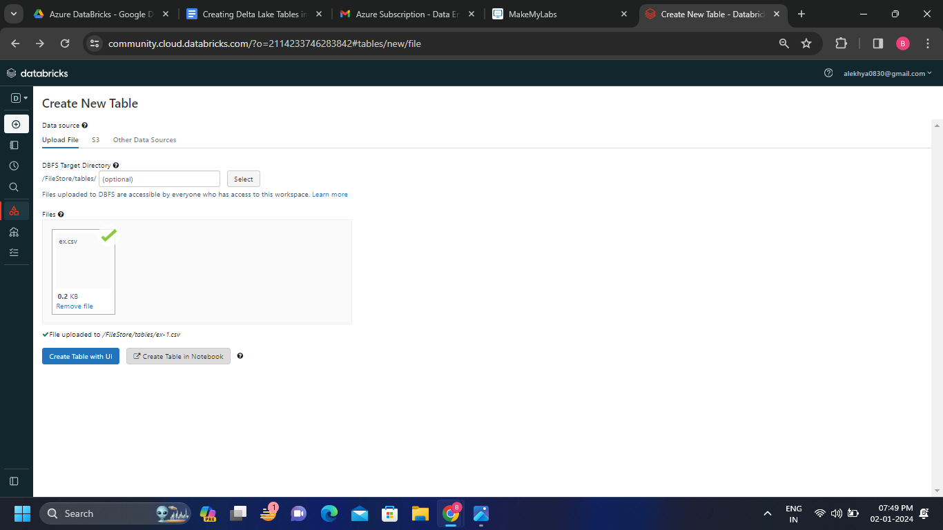**Step-2:** Create a new table and upload the local file into it and click on create table in notebook or UI.

**Step-3:** We will get the following notebook and the notebook is connected to the current cluster. Run the cells inside the notebook.

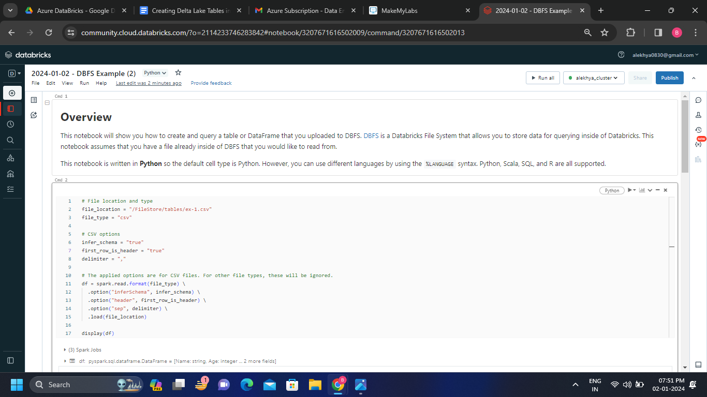

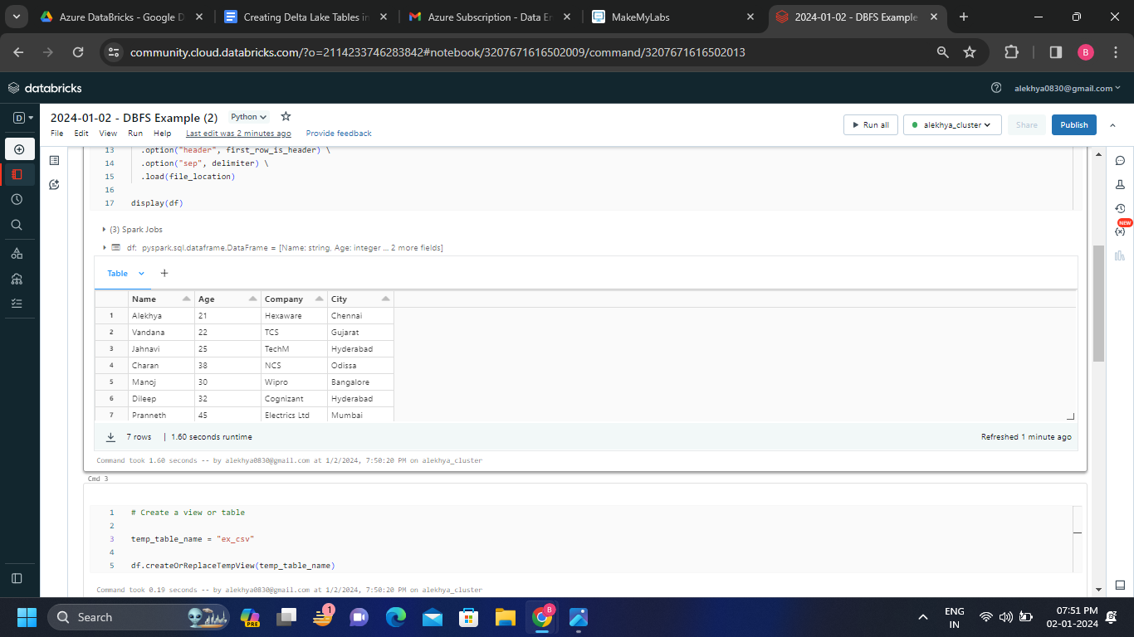

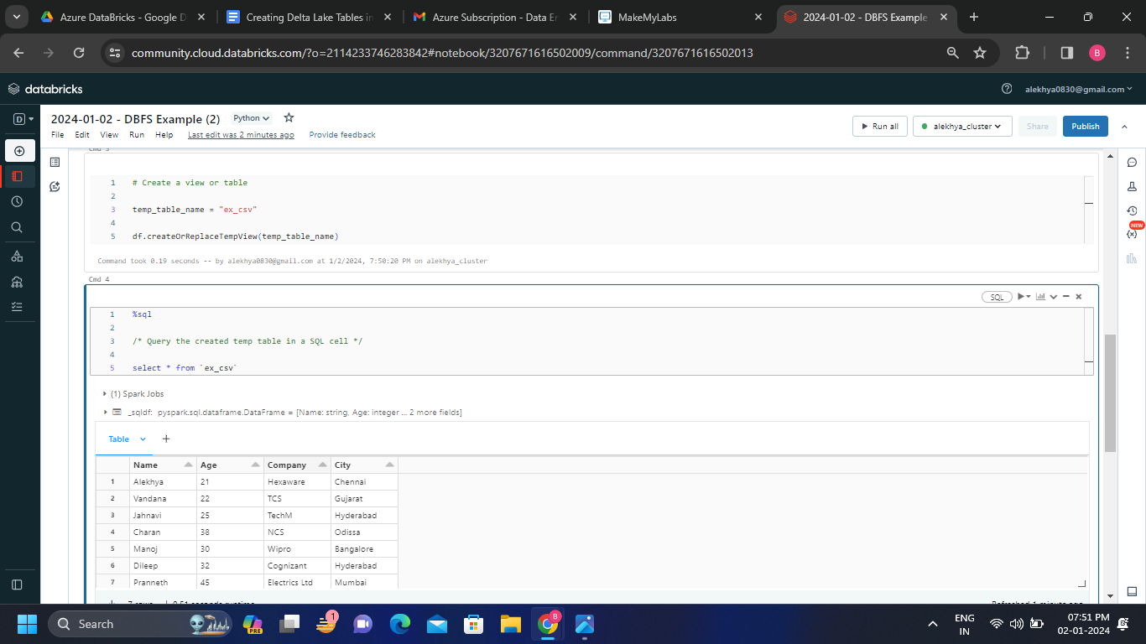

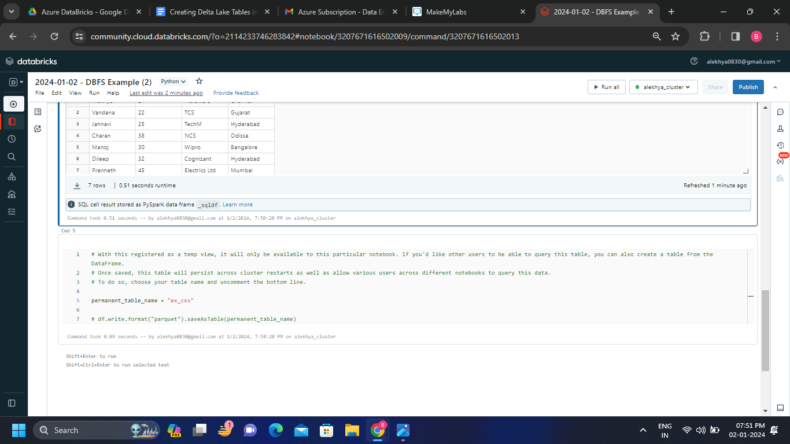

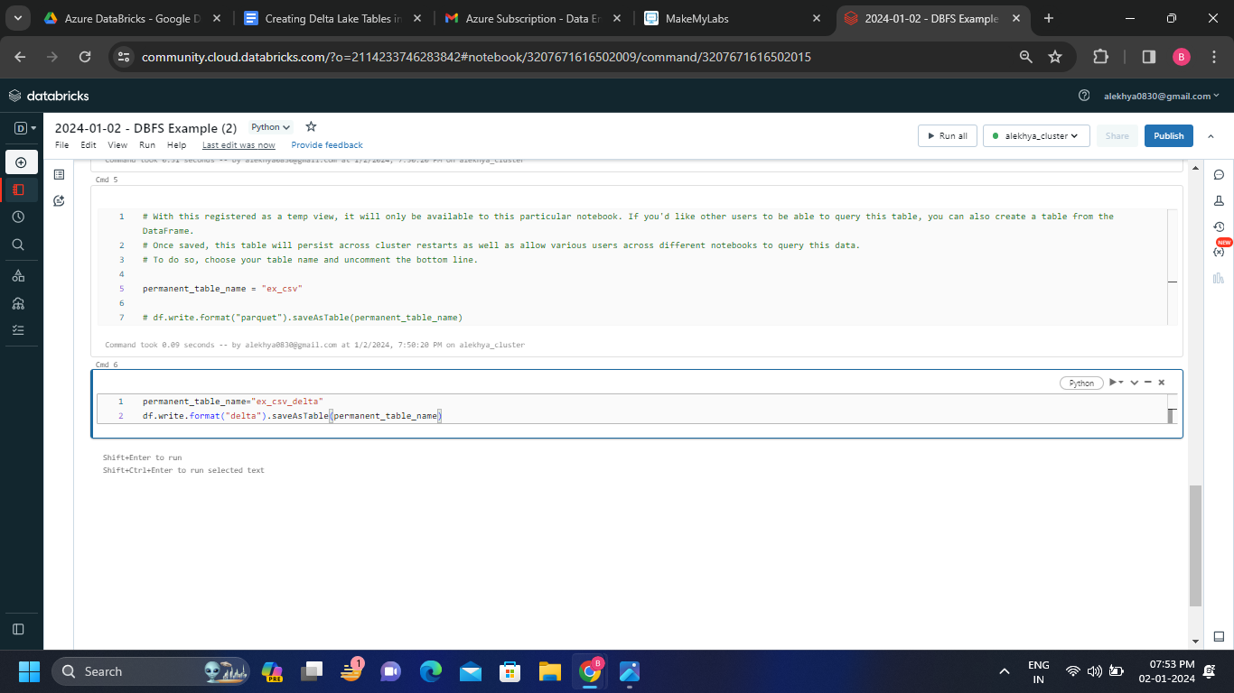

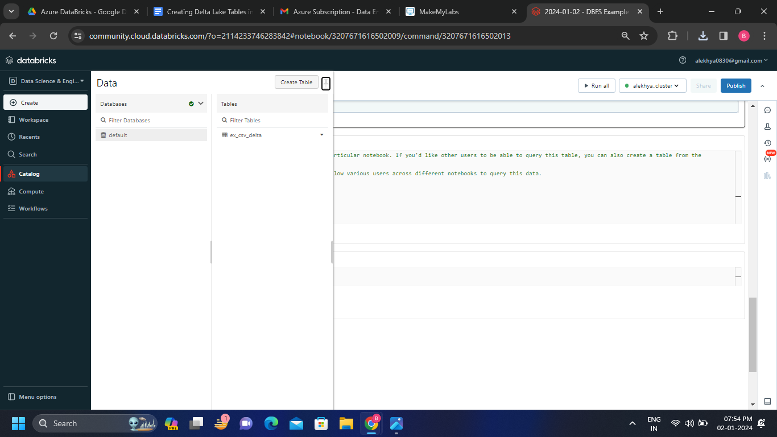**Step-4:**  After clicking on the catalog we can see the delta table that is created.

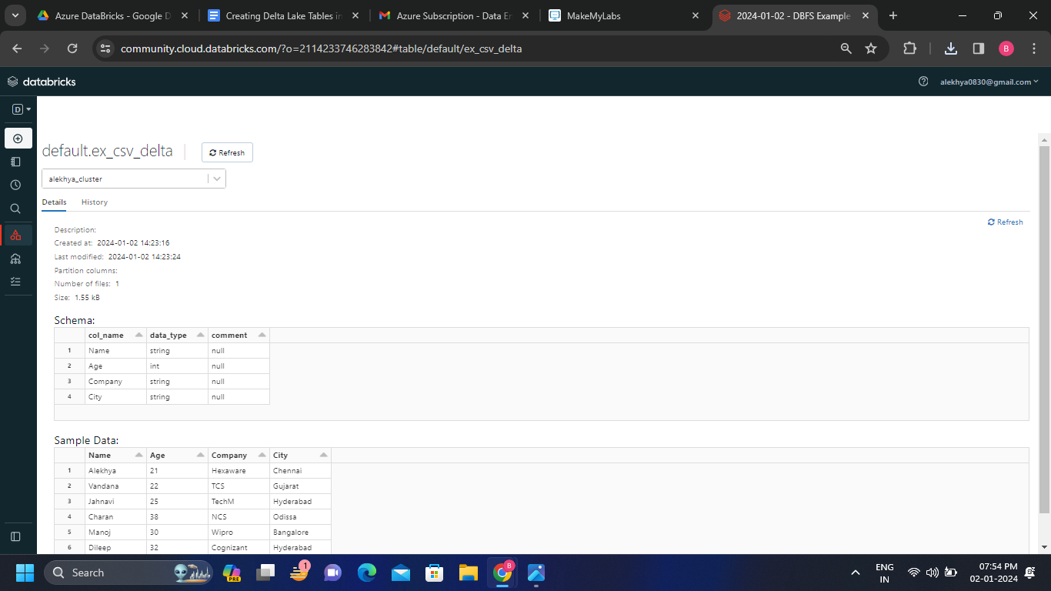**Step-5:** If we click on the above delta table we can see the details of the table which is Schema and sample data of the table.

* We can alse see the history of the delta table.

